Fall 2014 Region V Workshop
October 24th, 2014
Keiser University-1500 N.W. 49th Street
Ft. Lauderdale, FL 33309- Auditorium
(954)776-4456 ext. 195

Arrival/Sign in–------------------------------------------------------------------- 8:00 AM - 8:30 AM

Welcome and Introductions------------------------------------------------8:30 AM – 8:40 AM
Christine McDonnough

Getting Involved with FAFSA---------------------------------------------- 8:40 AM – 8:45 AM

FAFSA COMPLETION PROJECT-------------------------------------------- 8:45 AM – 9:45 AM
DR. VIERA

Break---------------------------------------------------------------------------------------9:45AM – 10:00AM

Verification for clock hour schools---------------------------------10:00AM – 11:00 AM
Robart whiting

Break--------------------------------------------------------------------------------------11:00AM – 11:15AM

State update--------------------------------------------------------------------------11:15AM – 11:30AM
Lori Auxier

Customer Service---------------------------------------------------------------- 11:30 PM – 12:30PM
Travis Brown

Lunch------------------------------------------------------------------------------------ 12:30 PM - 1:30 PM

Default Prevention-----------------------------------------------------------------1:30 PM – 2:30 PM
Jesse Marquez

leadership--------------------------------------------------------------------------------2:30 PM – 3:30 PM
Dr. Richard Mordi

Questions/Closing----------------------------------------------------------------- 3:30PM – 4:00 PM

Driving Directions to Keiser University – Fort Lauderdale Campus
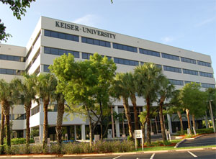
Keiser University-1500 N.W. 49th Street
Ft. Lauderdale, FL 33309- Auditorium
(954)776-4456 ext. 195

Directions:
Take Interstate 95 north or south to Commercial Blvd. Exit west and continue about a quarter mile past Powerline Road. On the left-hand side look for Spectrum Business Park and take a left-hand turn onto Spectrum Blvd. Follow Spectrum Blvd. until you see a six story, gray building with Keiser University across the top.

