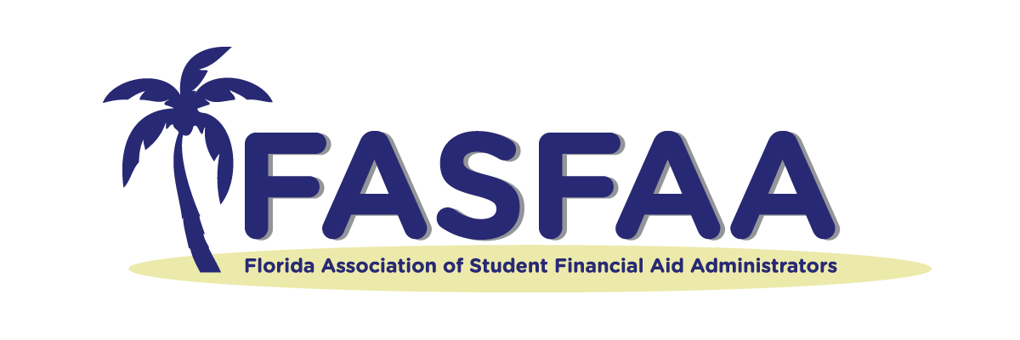
Executive Board Report

Why am I here?

Goals

Motion/ Action Item(s):

Policy & Procedure: Changes/ Recommendations:

Recent Activities

Accomplishments

